Paul Stewart writes about his picture story books

Wings!
Brian The Brave
A Little Bit of Hush
Mabel and the Big Wide World

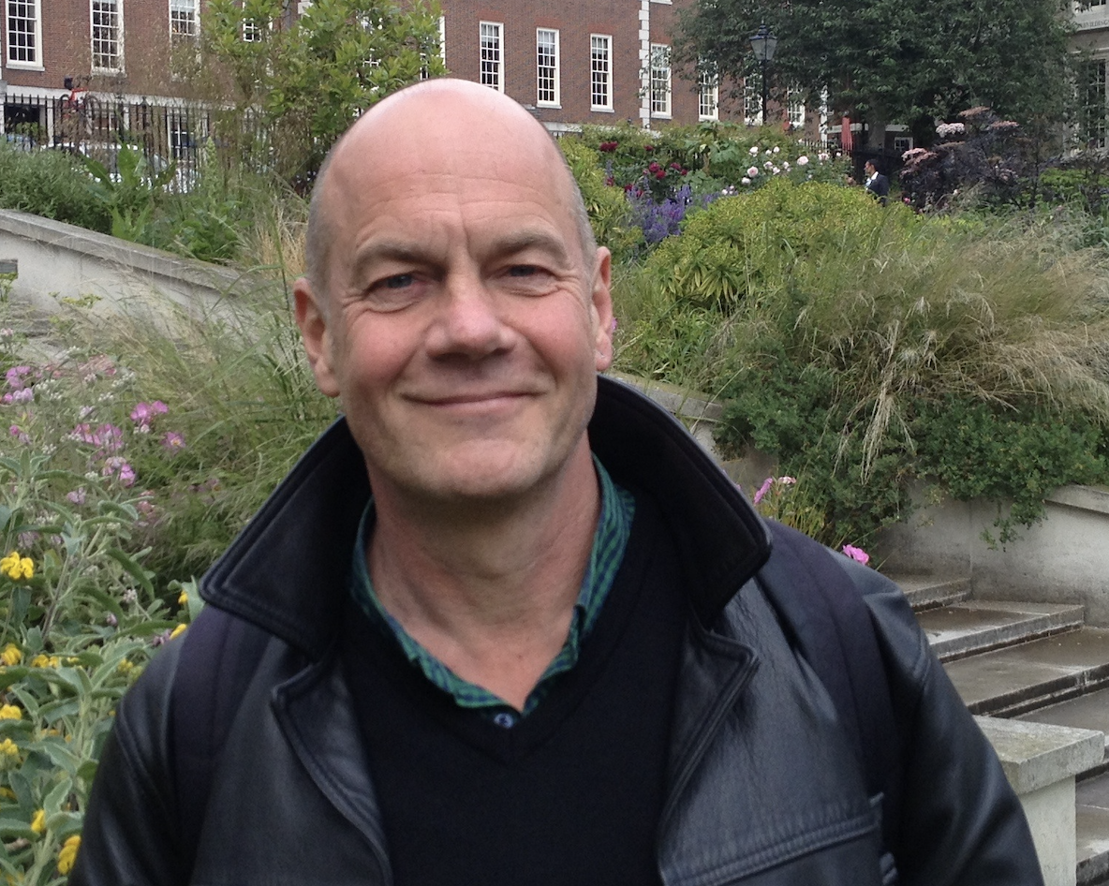

Big Issues for Little People

As a young reader, I loved it when I discovered that a character in a book saw the world in the same way that I did. It was both exciting and reassuring to realise I was not alone, but that my ideas, my feelings, my experiences were shared by others. Later, as a writer of books for children, I found that there was nothing more rewarding than reading aloud to a group and seeing that look on some of their faces when they too suddenly realised that the words they were hearing chimed with something in their own lives.

Wings tells the story of a penguin who is desperately sad because, unlike most of the birds he knows, he cannot fly. The others try to console him, but Penguin feels like a failure. It is only when their attempt to help him experience flight goes wrong, and he drops down into the ocean, that he discovers his own special skill. He can fly after all. Not in the air, but in water. The idea for the story came from various school visits where certain children felt they were not succeeding because their skill set lay outside the standard curriculum. One girl told me she hated reading, but then revealed that she’d built a kit radio the previous weekend. No child should ever be made to feel a failure: a rounded education must explore their interests and encourage their strengths.

Brian the Brave had a very different starting point. When my daughter was in the infants, she came home one afternoon upset about something that had happened. There was a group of four girls in her class. One afternoon, three of them decided to wear yellow socks the following day – and they then refused to play with the fourth girl because she was wearing white socks. ‘It was just so stupid and horrible!’ she told me. And, of course, she was right. Being excluded from a group because of something a bit different can lead to the worst kind of bullying. In the story, Brian – a sheep with white wool and curly horns – learns, and then shows the other sheep, that embracing difference and working together is always best.

The times when covid forced the country to go into lockdown were strange for all of us. With less traffic, fewer aeroplanes and almost no-one out and about, the country became a much, much quieter place. But not all moments of silence are the same – the pause between a flash of lightning and the sound of thunder is quite different from the silence when a bird falls still because of a passing fox. As I became increasingly aware of these differences, the idea for A Little Bit of Hush was born. Mother Squirrel – with the help of Owl – sets out to capture those individual moments of ‘hush’ so that her little ones can go to sleep, despite their noisy neighbours. It is a story about mindfulness; about being aware of your surroundings; and how, even though the world has become a noisy place once more, it is still possible to find moments of peace and quiet inside it.

The most recent book of mine that Otter-Barry Books has published is Mabel and the Big Wide World. Also inspired by covid and the long-term effects it has caused, it is perhaps the most important book I have written. During the lockdowns, children were not allowed to leave their homes; were unable to play with their friends; were frightened even to see older family members for fear of infecting them. This has, as is well documented, led to a rise in anxiety among the young that is proving difficult to overcome. In the book, Mabel, a young mouse, is terrified of leaving the safety of her barn because of the unspecified dangers of ‘great big hairy things and teeny-weeny scary things’. With the help of her brothers and sisters, she finally conquers her fears and steps outside to explore the big, wide world for herself. The message is clear. Missing out on something wonderful because of worries and uncertainty is the worst thing of all.

All four of these books, with their different themes, have been brought to life by Jane Porter’s amazing artwork. She has managed to make the big issues in the texts totally inviting for the little people they were written for. In each book, Jane has used intricate collage to give life and personality to the main characters, as well as creating colourful worlds for them that exactly match the way I’d envisaged them, but was unable to reproduce myself – for much like Penguin and his inability to fly, there are some things that this writer finds impossible to do. I cannot draw for toffee!

From Paul Stewart, July 2024

